June 4, 2013
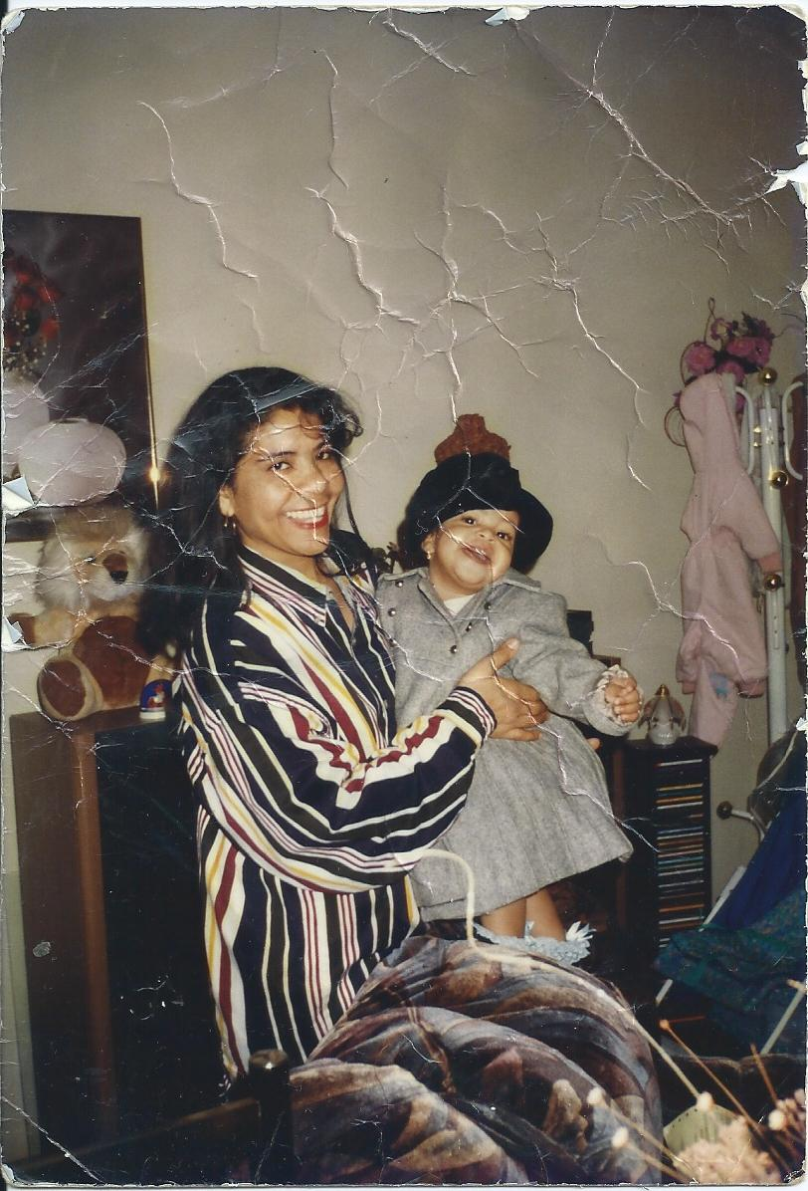

Regardless of the countless pictures my parents had taken of me because I was their only child, I still think back to one of my favorite photos: a candid shot of my mother and me as we’re about to go outside. Just behind us is the living room of our cluttered, too small apartment. The stereo, picture frame, stuffed lion, and coat rack, all long gone, remain behind us. My mom is holding me as I stand on our couch wearing a great, big, wool gray coat with some frilly socks - ones that didn’t really match. I can see my mom, with her wild, curly bangs covering her forehead wearing my father’s oversized shirt as she flashes her famous, toothy smile at the camera. In her arms I look more than happy to be wearing a black fedora-like hat, one that’s probably 5 sizes too big for me. Despite the fact that the hat is bigger than my whole head, I still manage to pose for the camera. This moment, frozen by this snapshot, captures a sense of happiness, and carelessness in my life. This photo captures a period in time where I didn’t care how ridiculous I looked, but also a time when I was still young and naive about how I would be perceived in the world.
When this photograph was taken, my family was still a family of three; my mother and father were still together and I wasn’t the reserved girl I am today. When I was younger, I used to love being on stage; I was always comfortable being the center of attention. Whether it was strutting down the runway for my modeling shows, or even dancing for a school presentation, I loved having all eyes on me. I remember several occasions where I would to dress up in my modeling couture, with a flashlight as my microphone, and sing in front of anyone who would listen and have him or her videotape me. Thinking back to that time now, the idea of being in front of a group of 10 people, let alone hundreds, makes me anxious. Just the idea of having everyone watching me and my every movement, the same feeling that used to give me a rush of adrenaline, is now the source of one of my fears.
My fear of attention probably started around the time my parents began their separation. As I started to become more aware of my parents’ growing distance and constant bickering, I also began to become more aware of smaller details in those around me and myself. I started noticing small things I didn’t like about myself. I was convinced that other people would have this same ability; that they would easily pick out these flaws. Sadly, this made me become more self-conscious and fearful of judgment of others, causing me to become distant when encountering new people. Soon after, I stopped modeling. I no longer wanted the attention, I no longer wanted to have a crowd “aww-ing” at me, and most importantly, I didn’t want to risk looking stupid. To this day, I am very resistant to show anyone those pictures of my modeling days, worried that they’ll think that what I used to love doing was ridiculous.
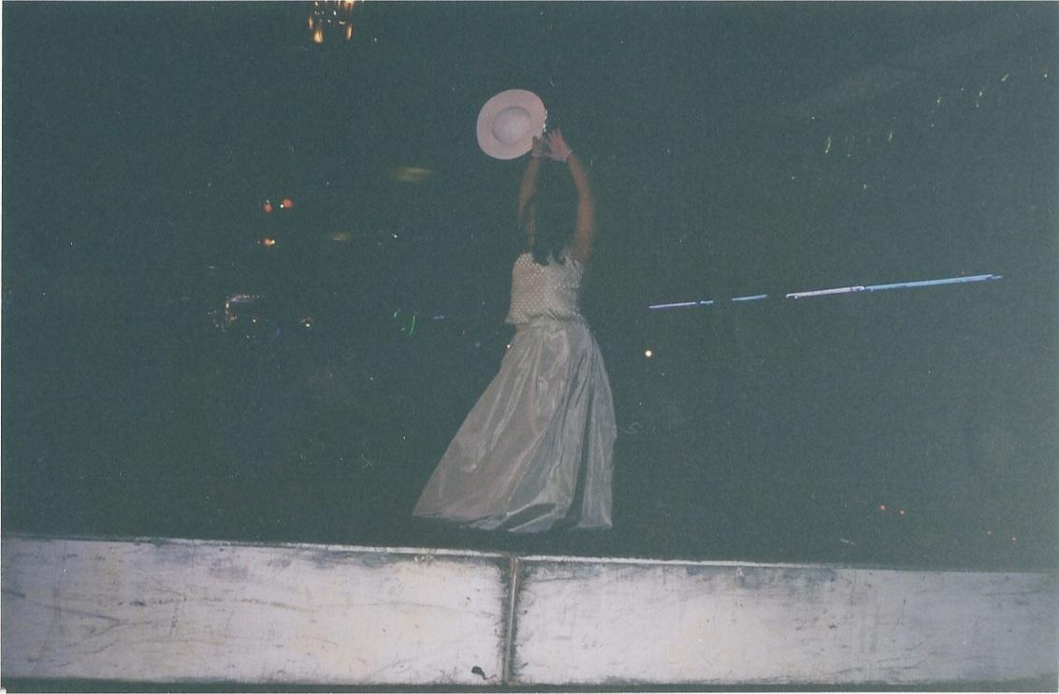
Growing up, I had no idea my carefree nature would be replaced by a timid and hesitant character. I wish I had known how hard getting older was going to be and how growing up really is; once you grow up, you get sucked into the idea of trying to meet everyone’s standards but your own. I never imagined that half of the furniture I was all too familiar with would be gone, along with my father. I never imagined that up until today, it would just be my mom and me. I never imagined that my already strained relationship with my father would become a nonexistent one. Looking back to what I remember from my younger years and older photographs, I wish I could go back in time and shake myself to stop from thinking all those discouraging thoughts at such a young age. Those thoughts about judgment, and embarrassment have all held me back from doing some potentially great things, whether it be making more friends, participating in the ballet class I secretly wished I had the courage to join in 2nd grade and even now, applying for a job. Although I realize that the effect of my parents’ separation has had a toll on me, I do know that there is still time for change. As I grow older and am soon moving on to college, I know that this is my opportunity to reshape myself into the person I used to be, perhaps an even greater version. In college, I have the chance to start over, to start performing in front of people again, to join a club and even be daring enough to be a leader; all I have to do is be willing to take the chance and bring back the unfettered Luz in the old, wrinkled photograph.

