Fish Tales
Grades 1-2

Step by Step

Standards Addressed

I addressed two separate standards in these lessons, both under the heading of Production and Distribution of Writing, which are slightly different for my first and second graders.

English Language Arts Standards-Writing

Grade 1
CCSS, ELA Literacy.W.1.3
Write narratives in which they recount two or more appropriately sequenced events, include some details regarding what happened, use temporal words to signal event order, and provide some sense of closure.

Grade 2
CCSS, ELA Literacy.W.2.3
Write narratives in which they recount a well-elaborated event or short sequence of events, include details to describe actions, thoughts, and feelings, use temporal words to signal event order, and provide a sense of closure

Grade 1
CCSS, ELA Literacy.W.1.5
With guidance and support from adults, focus on a topic, respond to questions and suggestions from peers, and add details to strengthen writing as needed.

Grade 2
CCSS, ELA Litereacy.W.2.5
With guidance and support from adults and peers, focus on a topic and strengthen writing as needed by revising and editing.

Teacher Licensure Number: 293175

I. Introduction

What knowledge and skills did this instruction help your students learn?
This instruction helped my writers organize their writing chronologically with a definite beginning, middle, and end. They learned that temporal words help cue the reader to the order of the events as they unfold. It also helped them learn to choose their words carefully and use detail to describe the events and characters’ experiences more succinctly. Sharing their stories with teachers and peers gave them the experience that writers write for an audience, and additionally, that the audience can give them important feedback about what they have written and help them answer some important questions: Does my story make sense? Did I paint a clear picture of the characters, setting and plot? Is my problem interesting? Is my ending satisfying? The students learned that understanding how their writing is received can give them ideas as to how to revise it.
How did this segment fit in with previous and continuing instruction?
My students have been writing all year. I let them use a combination of drawing and writing and slowly push them to write more and more. I want to keep their voice in everything they write, so I allow plenty of free-writing time and encourage them to write phonetically so that they can use the words they want, and not only the words they can spell. Throughout their two years in my class, they keep building on what they already know and slowly increase and refine their writing skills. The class is multiage, so my expectations are on a developmental spectrum and I individualize instruction to meet the needs of each child. At this point of the year, they have spent hours drawing and writing in a variety of genres. I have taught them many things about what writers do through mini-lessons at the beginning of Writing Workshop. They have been shown how to write stories with a beginning, middle and end. They have been introduced to the six traits of writing: ideas, voice, word choice, organization, sentence fluency and conventions. They have learned a class protocol to peer critique using the sentence starters I notice . . . and I wonder. . . They have been shown how to use blue pencils to revise and to cut and tape their pieces together to add and take away, and they have practiced editing with red pencils to refine conventions: capitalization, punctuation and grammar. During the two years they are in my class we revisit the skills they are developing and, in time, these skills naturally transfer to all their writing.
How did this segment integrate skills or content from more than one subject area?
Writing our “Fish Tales” was part of a yearlong integrated unit focused on investigating our 150-gallon fish tank. The tank has a school of African Cichlids and a large Amazon Plecostomus living in it. This year’s curriculum was organized around this investigation. All of their science learning revolved around the tank: they learned about fish anatomy, form and function, life cycles, adaptations, water chemistry, and animal behavior. They also learned how to collect, organize and interpret data based on work with the fish and the tank. They learned how to write letters thanking experts who visited the classroom and they learned how to diagram and document their learning in science journals. In understanding how the fish interact with one another, important social and emotional themes were brought into focus as well. The students could easily take the perspective of the fish in their stories because they had both a cognitive and emotional investment in the fish and their day to day life in the tank.
How did you organize the educational setting to enhance student learning in this segment?
I organized the educational setting to enhance learning by setting up a physical writing workshop early in the year and teaching my students how to use it. Each child has a writing folder kept in a file cabinet where there are also file folders filled with a variety of writing papers and graphic organizers that I have found or created for different forms of writing. There is also a writing center with baskets for different drafts of their work. Above the baskets is a display that served as an anchor chart for the work they were doing (Resource 1). Learning targets were displayed not only on the anchor chart, but also on privacy castle the students used when they were writing (Resource 2). We used a graphic organizer “The Story Mountain Planner” (Resource 3) and special paper that that I created to reflect the mountain’s organization of a story into five parts (Resource 4).
How did you differentiate instruction for students with diverse needs?
I differentiated instruction for students with diverse needs by varying the amount of support I gave them and by adjusting my expectations to their zone of proximal development. Although the learning targets were explicit, I interpreted them according to the needs of my individual students. My first graders were allowed to build their stories around their drawings and include detail in picture more than in word. My second graders were asked to build more of their imagery more through the words they used. I edited the work of my first graders, typing their first draft so they could work off of a corrected version when revising. That way I knew they could all read what they had written for the critique and wouldn’t be confused by their sometimes cryptic phonetic spelling. My second graders were expected to edit their first draft before the critique and afterwards revise on their own. For my youngest first graders, I helped by taking some dictation. Emergent writers can spend all their energy encoding, so I like to scaffold by writing down some of what they say so that their wonderful ideas don’t get lost in the shuffle.

Teacher Licensure Number: 293175

II. Instructional Record (3 to 5 consecutive or connected hours)

The Story Mountain Planner
Whole Class-10 1st graders, 10 2nd graders
1 hour duration
Connection  Last week I told you that we would be pretending to be a fish in our tank and imagining what it would be like to be there and that we would then write a story to share our ideas with others. If we were a fish in our tank, what would be happening? What would we be feeling and thinking? What would we be doing?  Yesterday we talked about some of the books we have read in Reading Workshop and noted that writers like to build their story around a problem. We saw that interesting problems made interesting stories. We thought about what our problem might be if we were a fish in our tank. Then we did a pair/share and wrote down our best idea for a problem on a sticky note. You remember Amy (pretend name) said that her problem was going to be that the tank was very crowded.  Today I am going to share a graphic organizer with you called the Story Mountain Planner (Resource 3). This planner is going to help us build our stories and meet our learning targets.  Let’s read our learning targets. (Students are called on to read these aloud)  WRITING LEARNING TARGETS  (Resource 1)  First Grade:  - I can plan a story with a beginning, a build-up, a problem, a solution and an ending.  Second Grade:  - I can plan a story with a beginning, a build-up, a problem, a solution and an ending. | My mini-lessons begin with a connection. This is quick and puts the day’s lesson into the context of the class’s ongoing work. Often the connection begins with a sentence or two in which I recapitulate yesterday’s work, followed by a precise example that illustrates a generality. I end the connection by telling them what I will teach them today. By the end of the connection I have explicitly named what I will teach.  I introduce our new learning targets by translating the standards into child friendly language and writing them on our anchor chart. Although we will be working to reach multiple goals over the next few days and the chart includes everything we are aiming to accomplish, I introduce the learning targets a bit at a time so I don’t overwhelm my students. I want them to focus their work today on the first part of the first target and I have revised this target somewhat to better fit today’s lesson replacing the word “write” with the word “plan”.  There is always a danger that my modeling will over-influence their writing. I had them write down the dilemma ahead of time to keep this to a minimum. I want these stories to be unique and not copies of my example. By already committing to a problem, which they did without conferring with others, I can partly prevent this from happening.
Teaching: Demonstration  Here is the Story Mountain Planner. I want to show you how it can help us meet our learning targets. Let me demonstrate how it works and later you can have a go.  Remember, yesterday my idea for a problem for my story was that I was a fish who was used to living in a fish bowl alone in a house, and then I got brought to school and put in a tank with a lot of other fish. Remember I said that I was scared of the other fish so I just hid. This planner is going to help me build a story around that problem.  Now I need to think of what came before my problem, before I was put in the fish tank. What does the reader need to know at the beginning of the story? In the section labeled the beginning I need to introduce my characters and my setting. We have done this before, when we first learned about story writing, remember? This bubble says (read and underline with me), Introduce the main characters and describe the setting. What will your opening sentence be? At the beginning of the story I live in a fish bowl in a house. My characters are Alicia, the girl who owns me, and me, I am a goldfish. I think my first sentence will be, I am a goldfish. I live in a fishbowl at Alicia’s house. I can add more description later. This is a planner so I want to only write a little right now. Questions?  Then I go to the second section. It is called the build-up. This bubble says, (read and underline with me) What things happen? What clues are there? What is said? How do you build up the excitement? I have to think, why do I, the goldfish, get put in the school tank? I know, I will say that Alicia is moving and she has to give me away. She wants to make sure I am taken care of, so she takes me to her school where her friends will look after me. Again, I don’t have much space to write so I will just jot down my ideas. Alicia moving to France. Mom says she must give me away. Alicia gives me to school where her friends are. Is this making sense?  The problem or dilemma is the next part. This bubble says, read and underline with me, Things might go wrong! Is there a mystery, or do terrible things happen? Are there any disagreements? I have my sticky note from yesterday. I will write down my problem from my sticky note: it says, I get put in the tank. There are other fish there. I am afraid of them. I hide from them. What do you think so far?  Now on to number 4 on the planner. This is called the resolution. The bubble here says (read and underline with me), How are things going to be sorted out? Problems have to be solved and people (or fish) made happy again. I will write, I hid for a week then fish peeked in to my hiding spot and they reassured me that they were nice. I came out. Any questions about what I am doing?  The last part of my planner, number 5, is called the ending. This bubble says (read and underline with me), Does the story end happily ever after? What have people learned? Have characters changed? Here I will write how I feel. I will say, Now I was happy. I will also say how I had changed. I will say, I used to live alone in a bowl and now I live in a big tank with lots of friends to play with.  There. I have my story planned out. I have a beginning, a build-up, a problem, a resolution and an ending. Do you see how I organized my story? Do you have any questions? Now you are going to do what I just did, only with your own wonderful ideas! | I teach the students by demonstrating what it is I want them to learn to do. I try to teach in a way that will connect with my students and make a lasting impression. Using a story of my own making usually does this. As I work, I do all my thinking out loud so that they can hear my process. I make sure that I monitor my group, noticing the expressions on their faces to see if they are confused and clarifying when needed. I am also reading all text on the planner aloud and asking them to read and underline as I read, so that my students who are emergent readers know what it says. This also keeps them focused on what I am illustrating at the time. I make sure I go through every step that I will later want them to go through so that they have seen exactly what to do. For some of them, this demonstration will be enough to release the responsibility entirely to them in the next part of the lesson. For others, more scaffolding will be needed.
Active Engagement-Guided Practice/Have- a-Go  Now I am going to give you a planner and I am also going to give you your sticky note from yesterday. First, please put your name and the date on your planner and put your hand on your head when you are ready to start.  Let’s begin: read over your problem on the sticky note. If you think you can fill out the planner by yourself, you may get a privacy castle and do so (Resource II). When you are finished filling out all five parts, stand behind your chair and when you see a classmate also standing behind their chair you may go with them to the other side of the class and share your work. Help your classmate make sure they have written a beginning, a build-up, a problem, a resolution, and an ending that make sense. Help them see if they have met their learning targets. (The students choose if they want to work on their own, or stay with me and work with support.)  For those of you who would like to fill out the planner with my help, let’s do it step by step, together.  Let’s start by writing your problem in the middle section first. When you have it written down, put your hand on your head so I know you are ready to go on.  Now let’s go to the first section. Think to yourself; who are my characters? Where are they in the beginning of the story? Turn to the person next to you and pair/share. Write what you told them in the first section and don’t forget you need to include who is there at the beginning of the story and where they are. (I move around the room and help as needed.)  Now let’s go to the second section. Re-read your problem and ask yourself, How did this problem come about? What happened right before the problem occurred? Think of a sentence or two, say it to your neighbor and write it down. (As they write, I move around the room.)  You have already written down your problem in section 3, so let’s go to section 4. Ask yourself, how does this problem get sorted out? What happens that make things better for your fish? Say what you want to write aloud and then write it down. One or two sentences will be enough. (I move around the room).  Now we are at the last box. Here is the ending. Think to yourself, is my fish happy now? Has my fish changed from the beginning of the story? Tell your ending to the person sitting next to you and then write it down. | After I teach something, I give the students the opportunity to try what I’ve taught. Some students are ready to work on their own, and I encourage them to do so. Many though, especially in my mixed age group, need more step-by-step support. I let them choose which approach they feel better with and if they start on their own yet still have questions, I encourage them to join the step-by-step group or work with a partner. I let them know that the first time we do anything new we find it challenging, and that the more we do it, the better we get.  While working with the step-by-step group I move around the room while they are working to see if they need help. I know my students well and usually position those who need the most help at the front table where I am located. I can help students in different ways, aiming for their zone of proximal development: I can take short dictation when a student is struggling to encode, I can ask a student who is unsure what to write a question, have them answer and tell them to write down what they told me, and I can challenge those who write very little to write a little more.
Debrief  Let’s all come back together for our debrief (The students who worked on their own, went over their work with a peer. If they were done early they read quietly until the group I was working with was finished. Now they return to debrief.) Turn to the person next to you and do a pair/share. Read what you have written on your planner, first one person and then the other, and we will revisit our learning targets. (They read their planners to a partner.)  Now let’s see how we feel we are doing. (I reread their learning targets, which are the same this time for both grades.)  First Grade:  - I can plan a story with a beginning, a build-up, a problem, a solution and an ending.  Second Grade:  - I can plan a story with a beginning, a build-up, a problem, a solution and an ending.  Thumbs up if you have completed your planner, thumbs to the side if something is written in each section but you have more to do and thumbs down if you are missing the beginning, the build-up, the problem, the solution or the ending. (The students show thumbs up, to the side or down) Good job!  Tomorrow we will be using the mountain planners we filled out today to write the first draft of our stories. | At the end of the workshop, after writing, we gather to revisit the work we have done. I find that students love to share their work and although we often don’t have time for many to share with the whole class we can use pair/share, making it possible for each child to read what they have written to at least one other person. I assign seats in my class when we write and I shuffle the students around day to day so that they are exposed to the work of many of their peers. I use different groupings to achieve different ends at different times; sometimes a student helps another, or at other times he or she learns from a friend.  We re-visit our learning targets as a group and self-assess at the end of each lesson. This helps the students keep the learning targets in mind and also helps them take note of their accomplishments and take responsibility for the work they do. I make a mental note of their self –assessment, add it to what I have observed during the course of the lesson, and later look over each individual’s work to see if there are any misunderstandings. I have a block of time in my daily schedule I call “Work & Play” when I can work with those who need more support while the rest of the class plays.

Writing the First Draft
Whole Class-10 1st graders, 10 2nd graders
1 hour duration
Connection  Yesterday we used our Story Mountain Planner to organize our story. We created a beginning, a build-up, a problem, a resolution and an ending. Now we can use our planner to help us write our story.  We will be drawing and writing the first draft of our story today. Let’s look at today’s learning targets. You will notice that one word has been changed and something has been added to the targets we used yesterday.  (Resource 1)  First Grade:  - I can write a story with a beginning, a build-up, a problem, a solution and an ending. In my story, I include some details about what happened and use “time” words like next, then and later.  Second Grade:  - I can write a story with a beginning, a build-up, a problem, a solution and an ending. In my story, I include some details about what happens and what characters think and feel and I use “time” or temporal words like next, then and later.  Who can tell me what I have added to the learning target? (Students answer) Yes, you noticed that now that we are going to actually write our first drafts. We will be adding detail and use words to show the order of the events as they unfold.  Temporal words can also be called time words: they are words like then, next later, eventually . . . (I write these down as I say them). Can anyone else think of a temporal or time word that shows us the order things happen in? (A few students speak and I add to our list, in a while, before, after, in two minutes . . .) | Again, I am making a connection to our previous work. I try to use the terminology of the planner: the more the students hear it the more they can make it their own.  I introduce what we will do today and add on to our learning targets, noting how they are increasing. I want them to keep focusing on the organization of their story into 5 parts, but also now pay attention to using detail to say more and using temporal words to show the order of events.  I interpret the word temporal, it is not a word young children are familiar with. I want my students to use correct terminology, but realize that scaffolding is needed. My students love to learn interesting and important sounding words!
Teaching: Demonstration  I have this special paper for you to use for today’s writing (Resource 4). You can see that there are two pages for each of the five parts of your story. One page has a place for you to draw a picture and add text and then the next page is text only for you to continue writing. You don’t have to use all the lines, but they are there if you need them and you will need them if you add lots of detail. Each part of the story has two pages. (I show them the paper) Let me show you how to work with the planner and the paper together.  First I take my planner and I read what I wrote yesterday, I am a goldfish. I live in a fishbowl at Alicia’s house. (I write Read what I wrote, on the board) I close my eyes and see what this would look like if it were a movie. I take a snapshot in my mind and draw a quick sketch of what I see. (I write Imagine the scene and take a snapshot on the board) I see a girl who is standing next to a table. On the table is a fishbowl, and I am swimming in the fish bowl. (I draw as I speak and write Make a quick sketch on the board). Now I write what I want to say. I have plenty of space to write, so I will elaborate on what I said in my planner. “Elaborate” means I can say more and add detail so the reader imagines what I imagine (I write Elaborate on the board): I am a gleaming orange goldfish. I live in a fishbowl at Alicia’s house. My fishbowl is on the table in Alicia’s living room and she loves to watch me swim around and around. Do you see what I did?  Now I move on to the next page and do the same thing only with part two, the build-up. I read what I wrote yesterday, Alicia is moving to France. Mom says she must give me away. Alicia gives me to her school where her friends are. I close my eyes and see what this would look like if it were a movie. I take a snapshot in my mind and draw a quick sketch of what I see. I see the same living room but Alicia’s mom is there now telling Alicia that they will be moving and that she has to give her goldfish away. Alicia looks worried. (I draw as I speak). Now I write what I want to say. Remember, I can elaborate and write more than I wrote on my planner. I write, Alicia’s mother tells her that the family is moving to France. They cannot take the goldfish on the plane, and Alicia has to give the goldfish away. Alicia asks her mother, “Can I give my goldfish to school so that my friends can take care of her?” Her mother says, “Yes! What a great idea!” How do you like it so far?  It is time for part three, the problem. Again I read what I wrote on my planner, I get put in the tank. There are other fish there. I am afraid of them. I hide from them. Again, I imagine the movie in my mind and take a snapshot and draw it. I see Alicia at school. I am in a bag filled with water. The teacher is there, opening the top of the tank and Alicia plops me in. I see all the other fish and quickly swim to hide under a rock. I need to decide which part of my movie I will take a snapshot of to draw. I decide to draw a picture of the tank with Alicia and the teacher looking on, with me hiding under a rock with all the other fish swarming around the rock (I draw as I say this). I write, Alicia brings me to school in a plastic bag filled with water from my fish bowl. The tank is huge and then a woman opens the bag and I fall into the water. There are fish everywhere! I swim as fast as I can to the bottom of the tank and find some rocks to hide under. I am afraid of them and I tremble in my hiding place. Even when it is mealtime, I don’t come out to eat! I sure am glad I had so much space and could add all these details!  Now for part four, the resolution. I do the same things again: read what I wrote, I hid for a week then fish peeked in to my hiding spot and they reassured me that they were nice. I came out. I imagine it as a movie and take a snapshot. I draw: I am hiding under the rock looking scared and skinnier because I haven’t come out to eat in a week, and the fish are there peeking in at me. They are smiling. I write: I hid for a week. I was lonely and scared. If only Alicia hadn’t left and put me here in this horrible tank with all these scary fish! Then, (Did you catch that temporal word? What is it?) after a week, (again!) I noticed little orange noses peeking in my hiding spot. They were sniffing around and asking me to come out. They told me they were nice and were happy to have a new fish in the tank to play with. Slowly, I came out. Good resolution? What do you think? (Students respond)  We are at the ending now. I do the same thing I did for each of the other four parts: read what I wrote on the planner, I used to live alone in a bowl and now I lived in a big tank with lots of friends to play with, imagine this as though it is a movie, take a snapshot in my mind and draw. Here I draw myself swimming with my friends. I look happy. After I draw, I write, remembering to say a little more than I said on my planner. I am no longer afraid of the other fish, in fact I am happy to have so many friends. We play together every day. It is hard to believe that I used to be happy living alone in a bowl at Alicia’s house. I love my new home in the big tank at the school. (I turn and smile at my students) Wow, my story sure is growing! | I created a special paper for this activity (Resource 4). This paper corresponds to the Mountain Planner graphic organizer. In the past, one of the papers we used to write had only three parts: beginning, middle, and end. This paper supported the writing standards we were working with at the time. Now, I want to build on what the students have done in the past so I am expanding their understanding of organization with a five-part paper.  Again, I demonstrate everything that I want the students to be able to do, step by step. I think aloud, letting them in on my process. I want them to experience how I elaborate. I want to emphasize that we don’t simple copy what we have written on the planner to the new paper: that is what they would tend to do if left on their own. I interpret the word elaborate, another powerful word for them to learn and use. After I demonstrate each section, I pause to make sure my students are with me. I ask questions to keep them engaged.  We have used the movie/snapshot analogy all year when drawing and writing. In the beginning of the year, we used it writing wordless pieces, later we used it when we were learning about sensory images, and now we use it to write our five-part stories. We are constructing our understanding of story writing and collecting a box full of tools to use.  When I finish, I purposely don’t read my entire first draft to the students because I want the students to stay focused on the step by step process: reading the planner, imagining the scene, taking a snapshot, making a quick sketch, writing an elaborated version of what I wrote on the planner and then on to the next section. This is certainly enough to think about.  I write this process on the board as I do it for visual learners and point to this reference each time I do a step for the next four pages of my story. This will be a reference for the students that they can refer to when working on their own stories.
Teaching: Guided Practice, Have-a-Go  I am passing out your Story Mountain Planners from yesterday and your new paper. If you think you can write your first draft using the new paper by yourself, you may get a privacy castle (Resource 2) and do so. When you are finished, stand behind your chair and when you see a classmate also standing behind their chair, you may go with them to the other side of the class and share your work. Help your classmate be sure that they have drawn and written a beginning, a build-up, a problem, a resolution, and an ending that make sense. Make sure they have elaborated and written more than they wrote on their planner. For those of you who would like to draw and write your story with support, let’s do it step by step, together. Okay, let’s start! (Students choose which group they want to be in.)  Read what you have written in the first section of your planner. Close your eyes and see this part of your story and take a snapshot. You have 3 minutes to draw a quick sketch of what you see. Start now. (I turn over a three-minute sand timer) While they are drawing, I go around the room and help as needed.)  Now write what is happening in this part of the story. Write including more detail than you did on your planner. You have 5 minutes to write. Start now. (I turn over a five-minute sand timer.) While they are writing I move around the room and help as needed)  I repeat this for each part of their story. | Now again my class splits in two. Some students are able to go off and work by themselves while others need more support and stay with me. Standing behind your chair to show you are ready to share your work is a routine we use regularly, so the students are familiar with it.  This is not easy work for most first and second graders, so I want to provide all the help they need to succeed. I scaffold by breaking a big task into smaller, manageable steps, I manage time, and I move around the room so I can see that everyone is getting it. I also have those students I know will need extra instruction seated at the front table near me. When students cannot write all they want in the allotted time, I remind them they can write more at Work & Play. Both the Story Mountain Planner (Resource 3) and the special five-part paper (Resource 4) will be available from now on as one of the paper choices available. In the weeks that followed these lessons, many children used both when writing on their own during Free-Write.
Debrief  Wow! Look at all you have written! Congratulations! All you of have different stories to tell! Our stories will make a wonderful anthology of fish tales! (I call back the students who were working on their own.)  Please turn to the person next to you. Share your story with them, reading the entire piece and showing them your pictures. (They pair share.)  Let’s review our learning targets fist to five (student place their palms on their chests and show varying numbers of fingers depending on how well they think they met their targets: not met is shown with a fist; fully met is shown with five fingers)  I read the learning targets out loud and watch for their fist to five responses.  First Grade:  - I can write a story with a beginning, a build-up, a problem, a solution and an ending. In my story, I include some details about what happened and use “time” words like next, then and later.  Second Grade:  - I can write a story with a beginning, a build-up, a problem, a solution and an ending. In my story, I include some details about what happens and what characters think and feel and I use “time” or temporal words like next, then and later.  Over the next few days we will be reading our stories to the whole class. (The students cheer!) Our pieces sure are growing into wonderful stories. | After hard work, I want a little celebration. For my youngest students this lesson was rigorous. Sharing their stories with each other was rewarding. Many had not written more than 5 or 6 sentence pieces until this point and were delighted at the length of their stories.  We review our learning targets and self-assess. I take note and the students reflect on how they are feelings about their growing abilities.  I finish with a little glimpse into the future. The children are very excited that they will get to share their stories with the whole class! It is the joy of the creative process that I want to keep at the focus of their learning: learning skills in service to self-expression and delight!

Class Critique
Whole Class-10 1st graders, 10 2nd graders
3 hours total: 1 hour on 3 consecutive days
Connection  Last week we finished writing the first drafts of our stories that will go in our class anthology entitled, Fish Tales . . .“If I were a fish in our tank, this would be my story . . .”  Now that we have written our first drafts, we are going to read them aloud and see if we communicated what we wanted to and then make some revisions to tell our stories better. We will be using our class protocol for peer critique using I notice and I wonder to reflect on our classmates’ writing. Let’s look at today’s learning targets:  First Grade:  - With help from grownups, I can focus on a topic, respond to questions and suggestions from friends, and add details to make my writing better.  Second Grade:  - With help from grownups, I can focus on a topic, respond to questions and suggestions from friends, and add details to make my writing better by revising and editing. | Time to connect today’s work to the work we did last week. I taught the students how to revise last month and I introduced using blue pencils, carets, scissors and tape to revise their work. This method of revision comes from Lucy Calkin’s work with primary students. I want the students to understand that writing is a process. This is a big learning for them: especially my first graders who tend to be satisfied with their first attempts. By making revising interesting and exciting, I have more buy in.  I teach editing with red pencils from the beginning of the year: students always edit their writing before giving it to me. They circle the first letter of each sentence to make sure it is capitalized and underline the last word of each sentence, curling the line to circle the end punctuation to make sure it is there. First graders who are having trouble putting spaces between their words also put dots between each word. I individualize editing skills for each student; some are expected to spell all the words on the word wall conventionally and others are expected to check for capitalization of the word I, and all proper nouns . . . expectations are based on the zone of proximal development for each student.
Teaching: Demonstration  I will begin by sharing my story with you. I will sit in the big chair, and while I am reading my story I will make sure my paper lies flat in my lap so that when I speak, my voice goes straight from my mouth to your ears. I will read loud enough so that even those sitting in the back row can hear me and I will read slowly, carefully pronouncing each word so you hear every word I say. I will also read with expression, paying attention to my punctuation to make the story come alive!  After I read a page I will stop, show you my sketch, and then pick a stick. If your name is on the stick, I will ask you to please share a notice or wonder.  Do you see that I have a blue pencil, and a clip board? Why do you think I have these? (The children respond that I have them so I can revise). Yes, if I get good feedback from your notices and wonders I will have ideas about how to make my story better, and I will revise on the spot or if I want a bigger revision and will need to cut and tape, I will write down reminders of what I want to do later. Let’s go!  I read page one of my first-draft, reminding my students that this is the beginning and they need to help me make sure I introduce my characters and setting, I am a gleaming orange goldfish. I live in a fishbowl at Alicia’s house. My fishbowl is on the table in Alicia’s living room and she loves to watch me swim around and around.  I show my sketch and pick an equity stick (see explanation in next column) and call on someone to notice something about what I have just read. I ask them if I they can give me evidence of having introduced my characters and setting. The student chosen says they notice that I said I was a goldfish and that I was in Alicia’s house. Yes, I introduced the main characters and the setting. Someone else says that I used the word gleaming. Yes, I say, I want you to picture the goldfish the way I saw it in my snapshot, so I added descriptive words.  I read page two of my first-draft; Alicia’s mother tells her that the family is moving to France. They cannot take the goldfish on the plane, and Alicia has to give the goldfish away. Alicia asks her mother, “Can I give my goldfish to school so that my friends can take care of her?” Her mother says, “Yes! What a great idea!” I show my sketch and pick a stick and call on someone to wonder something about what I have just read. I ask them if my words were clear and made sense. The student chosen wondered why they were moving to France. I say that perhaps I should write why they are moving to France so that my readers know. I will make a caret right here and add to my sentence so it reads like this, Alicia’s mother tells her that the family is moving to France because her father got a new job there.  I continue demonstrating, reading my story and asking for notices and wonders. | I demonstrate, taking the students through each step I will eventually want them to do on their own. Implicit in this lesson are reading, oral language and presentation skills; I like to sneak a lot in to help my students grow strong!  Our protocol for class critique, which all the students are familiar with, involves 4 steps: I notice . . . I wonder . . . If this were mine, I would do this next . . . This gives me the idea to . . . Each part of the critique protocol is specially worded so that students make specific references to the work they are critiquing, notice the strengths of the piece first, ask clarifying questions if the piece is confusing, consider and comment on the next steps to be taken seeing writing as a process, and use other’s work to improve their own. I am focusing on I notice . . . and I wonder . . . right now to simplify things for my first graders.  I use equity sticks as part of a protocol called Cold Call. I ask the question and chose a stick instead of waiting for volunteers; this serves as an engaging and challenging yet supportive way to hold students accountable for answering oral questions, even if they are not sure of the answer. It also promotes equity in the classroom; students who normally dominate discussions step back and others get a chance to share their thinking.  Students who are being critiqued have been taught that they should consider carefully what their peers are saying, but that it is their story and the final decision to make a revision rests with them.
Teaching: Guided Practice, Have-a-Go  Over the next few days the children read their pieces out loud to the whole class, and make minor revisions in blue pencil based on what their peers and I notice and wonder. Second graders often use the last two phrases of our class critique, If this were mine I would do this next . . . and this gives me the idea to . . . By the time we read the last five stories, the first graders are adding these two phases too. | I have the second graders go first because they are more experienced and more likely to make longer, more thoughtful revisions. The second graders are giving the first graders another chance to watch before they do. Doing class critiques for every student is time consuming, but invaluable. During this process, I am able to help the children refine their critiquing skills, asking for concrete examples and teaching them that not all revisions are good revisions; they often wonder things that will take the story off track. I can help the group notice when a temporal word is used and other ways students are signaling time. I am also able to sit with each child as they read, support their presentation skills (can you hear her in the back row?) and help them with teachable moments with their reading (I have typed and edited the first graders’ stories so that they are easier for them to read. Many first graders are reading new words in their stories for the first time). I can individualize instruction on revision as well.
Debrief  At the end of the three days we gather and debrief.  Let’s revisit our learning targets. (I read the targets)  First Grade:  - With help from grownups, I can focus on a topic, respond to questions and suggestions from friends, and add details to make my writing better.  Second Grade:  - With help from grownups, I can focus on a topic, respond to questions and suggestions from friends, and add details to make my writing better by revising and editing.  Were you able to make small changes to your story based on the notices and wonders of your classmates and your teacher? A quick fist to five.  Now that we have shared our stories and had our friends help us improve our writing, we will have some time to work on our revisions tomorrow and we will be writing our second drafts in the days to come. Soon we will be ready to publish! | On the last day of peer critiquing, when all stories have been read, we review our learning targets together.  Again I use fist to five to not only get a quick feel for how the students are feeling about their work but also to see if their perception matches mine. Fist to five is used both as a way for students to take charge of their learning and for me to make a formative assessment. Success for each child looks different because I am teaching on a developmental spectrum and teaching two grades. After so much hard individual work and peer collaboration everyone has learned a lot. The fist to five reveals that all my students are aware of their achievements.

Teacher Licensure Number: 293175

III. Resources (maximum of 4 resources)

Resource 1-Writing Center with Anchor Chart

Resource 1 is the classroom writing-center. There are four labeled baskets, the first for writing that has been started, the second for writing that needs to be re-read and revised, the third for writing that needs to be edited, and the last for writing that is complete. Above the baskets is an anchor chart. This chart grows throughout the lessons and reflects what we have learned. It began with a posting of our writing norms and a review of the steps involved in writing: Draw/Write, Reread. Revise and Edit. The learning targets are posted on this display along with the Story Mountain Planner and the drafts I have written and revised as demonstrations. Also our Peer Critique Protocol is posted here:
- I notice . . .
- I wonder . . .
- If this were mine, I would do this next . . .
- This gives me the idea to . . .

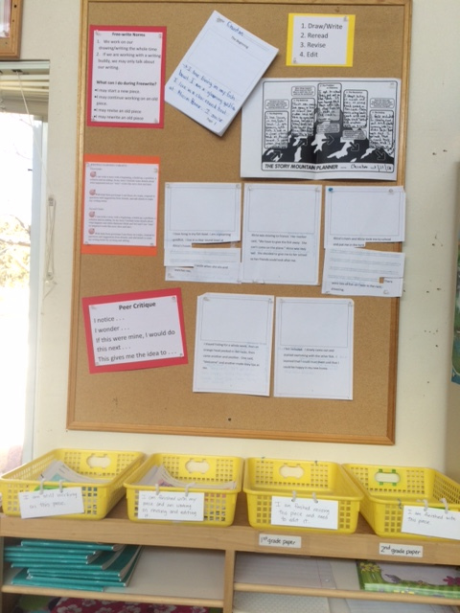
Resource 2-Privacy Castles with Learning Targets

Resource 2 is the privacy castle that the students use when writing. Each privacy castle has the relevant learning targets attached and a reminder to be quiet while working. A first grade castle is shown.

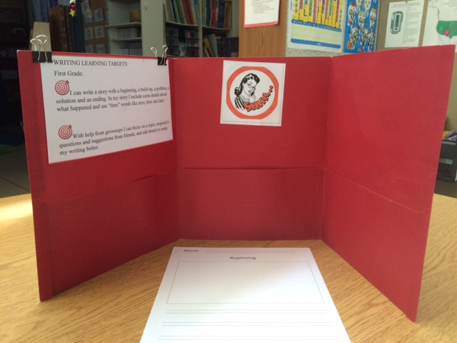

Resource 3: The Story Mountain Planner- the graphic organizer we use in the first hour of these lessons.

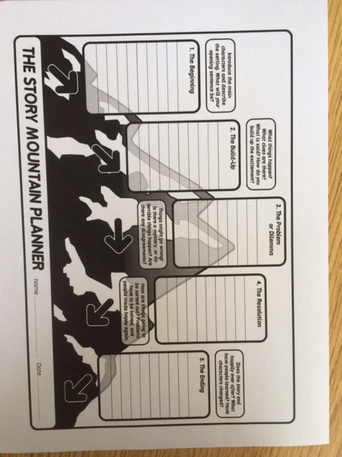
Resource 4: Special 5 Part Writing Paper

Resource 4 is the special paper I made to mirror the 5-part story mapped out in the Story Mountain Planner. For consistency, I have used the double lines the students use with their handwriting program, Handwriting Without Tears. The paper is one-sided so that they can cut and tape while revising, and the text only page shown on top is inserted after every picture/text page for all 5 parts of the story.

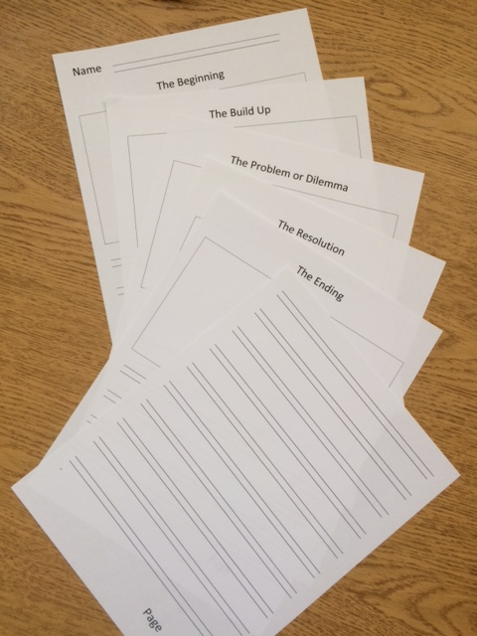
Teacher Licensure Number: 293175

IV. Student Work

Example of High Achievement-Grade 2 – Final Draft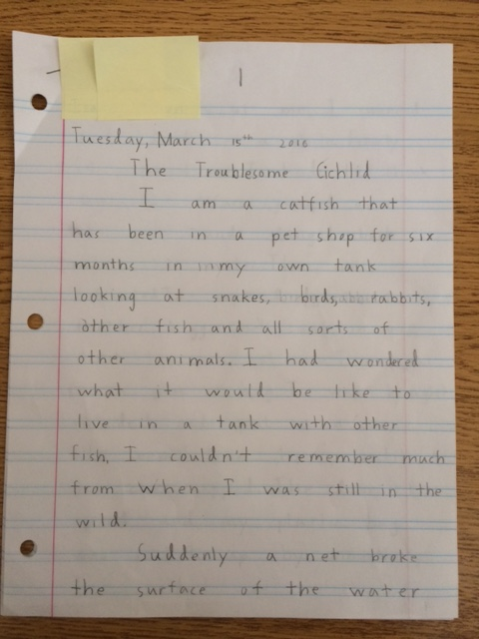
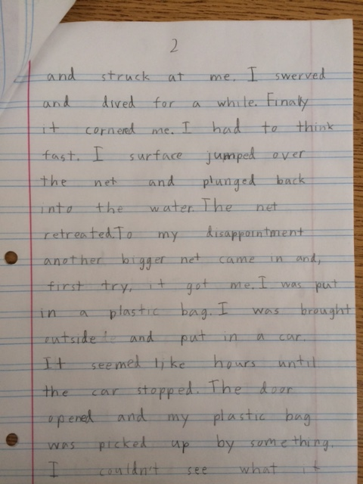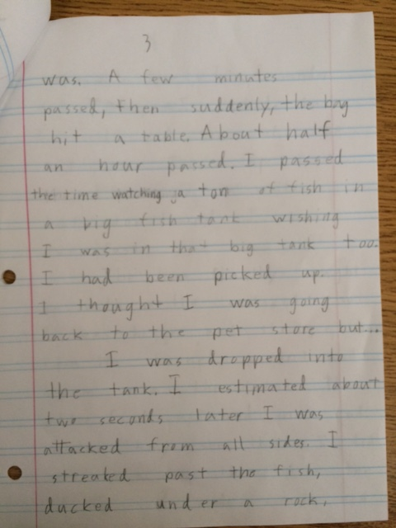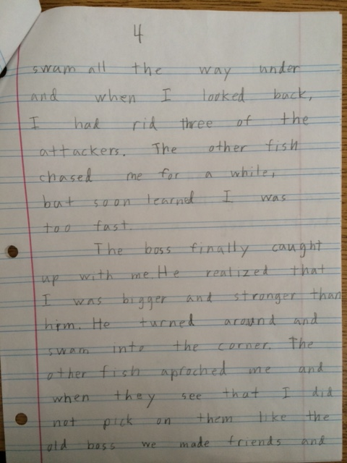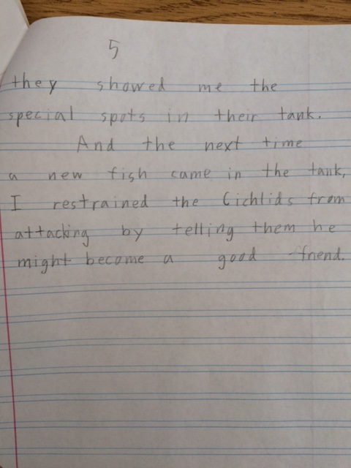

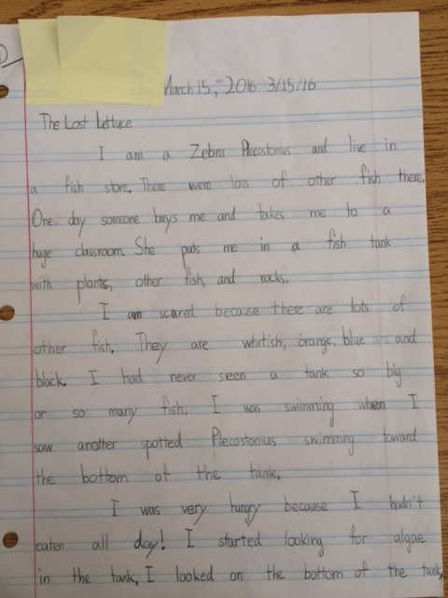
Example of Mid-Range Achievement-Second Grade Final Draft
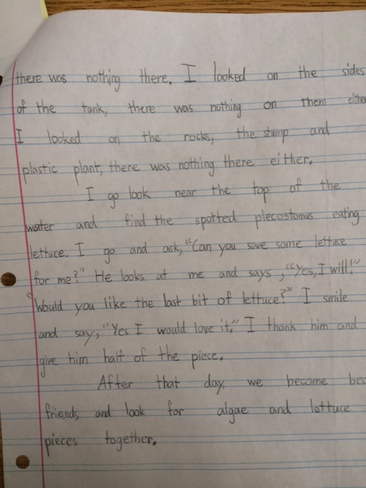

Example of Low Achievement-First Grade Final Draft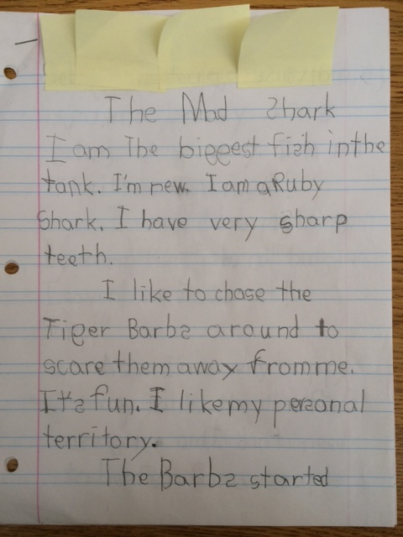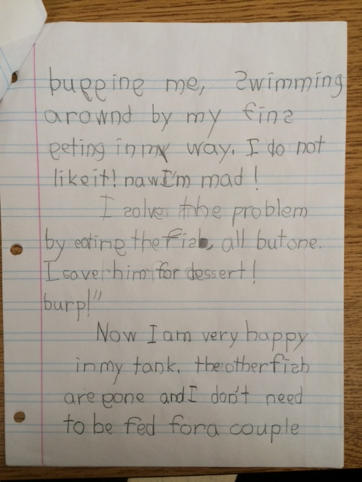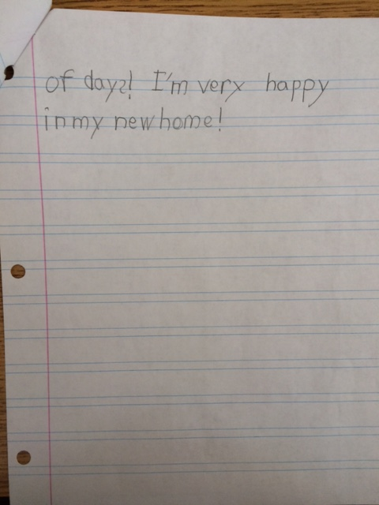
Teacher Licensure Number: 293175

V. Analysis of Student Achievement

- Explain the ways in which this class of students demonstrated their achievement.
Everyone met the learning targets for this group of lessons.
In the final draft of their stories, all first graders demonstrated success at writing narratives and recounting two or more appropriately sequenced events. They all included some detail regarding what happened and used at least one temporal word to signal event order. Most of them, inspired by the work of the second graders, also included details about the thoughts and feelings of their main character as well.
All second graders demonstrated success at writing narratives and recounting a sequence of events. They all included detail to describe actions, thoughts, and feelings and used temporal words to signal event order.
Both first and second graders were able to provide some sense of closure at the end of their pieces.
All first graders demonstrated that with guidance and support from adults they could focus on their topic and respond to questions and suggestions from peers, and then add some detail to strengthen their writing. Again, many exceeded this standard and made more complex revisions to their story. All second graders demonstrated that with guidance and support from adults and peers they could focus on their topic and strengthen their writing to varying degrees through revising and editing.

- Provide the criteria for determining different levels of achievement.
I created a simple rubric providing the criteria to determine different levels of achievement. This criteria was based on the standards I had chosen for these lessons, but I was also looking for more than that: growth in general, amount of support each student needed to do what they did, and especially effective writing techniques that I could point out to the group even if they weren’t related to our learning targets. I wanted to see if my students met their learning targets but also if they were growing as writers, especially if the writing skills not necessarily the focus of this group of lessons that we had learned throughout the year were showing up.
The rubric below allowed me to quickly assess the learning targets we were working on in each piece by circling the level of their achievement for each standard. The rest of my assessment was based by comparing their final draft to a pre-write I had them do before I introduced this set of lessons and on anecdotal records that I kept throughout the process. I think of assessment in terms of stars and steps: stars are the students’ accomplishments and steps are what they need to do next to keep growing.

Student Name:
Emergent | Developing | Mastery
Recounts two sequenced events | Recounts three or four sequenced events | Recounts more than four sequenced events.
Uses one temporal word to signal sequence | Uses two or three temporal words to signal sequence | Uses four or more temporal words to signal sequence
Includes two details regarding what happens | Includes two or three details regarding what happens, what the characters are thinking and feeling. | Includes four or more details regarding what happens, what the characters are thinking and feeling.
Provides some sense of closure by resolving the problem. | Provides some sense of closure by resolving the problem and saying how the character feels. | Provides some sense of closure by resolving the problem, saying how the character feels and describing how the character has changed.
With guidance and support from an adult focuses on a character for the length of the story. | With guidance and support from an adult focuses on a character for the length of the story and deepens our understanding by saying what the character looks like and how he behaves. | With guidance and support from an adult, focuses on a character for the length of the story and deepens our understanding by saying what the character looks like, how he behaves, what he thinks and feels.
With guidance and support from an adult responds to questions and suggestions from peers orally. | With guidance and support from an adult responds to questions and suggestions from peers orally and then applies what is learned through critique when revising. | With guidance and support from an adult responds to questions and suggestions from peers orally and then applies what is learned when revising and is inspired by peer stories to make other changes to their own work.
Adds detail by describing objects and actions. | Adds details by describing objects, actions, thoughts and feelings. | Adds details by describing objects, actions, thoughts and feelings, and shows instead of tells.
Amount and kind of support needed to complete the piece:
Stars:
Steps:

- Explain how the three students differed in their achievement.
My low achieving student ended up writing a delightful piece, but needed a lot of support to do this. Basing his assessment solely on his final draft and the rubric would have been misleading. He scores as developing in most categories but is an emergent writer. This is where knowing my students well and anecdotal records are important in authentically assessing their work. This student is an emergent reader and writer and prefers to draw pictures and write a single sentence per page. He needed a lot of encouragement and support to do more. He struggles with encoding and gets frustrated easily when putting his thoughts down on the page, so I worked with him throughout the process. He has a comprehensive speaking vocabulary, wonderful phrasing when he talks, and delightful ideas, but little of this comes through when he writes on his own. I wanted him to learn that he could translate the funny things he likes to say into writing he would be proud of. Stars: He met the learning targets, albeit, with a lot of support. Steps: He is working toward more independence.
My mid-range achieving student is a second grader and scored well on the rubric. I chose her as mid-range because there is something unfocused about her story. You can’t tell if the problem is that the fish is hungry or that the fish doesn’t feel at home. During a critique, one student wondered if the fish in her story was still hungry after eating only one piece of lettuce and this student changed her story to say that the fish gave half of this piece back to the Plecostomus which didn’t answer her peer’s queery. A very successful part of her story is when the fish is looking for something to eat. Her sentence structure really sets up a beautiful rhythm. Again, each student has their strengths and weaknesses, and I feel assessment needs to reflect both. The amount of support I gave her was minimal; she was one of the students who went off and worked independently on both the mountain planner and her first draft. Stars: She meets the learning targets. Steps: She needs to stay focused on the problem and revise in response to critique.
My high achieving student scored mastery on my rubric. This student learned how to organize a story from this group of lessons. In his pre-write, he spent over an hour writing the beginning of the story and was unable to keep up the momentum. His piece petered out; all introduction, no middle, no end. He is a second grader and writes beautifully descriptive action. He uses exciting verbs and his piece has many examples of temporal words and phrases. This high achieving student chose to work on his own with the mountain planner and on his first draft. His revisions were in direct response to what his peers said. He needed support to edit. Stars: He mastered the learning targets. Steps: He needs to work on writing conventions: staying in tense and spelling.
- Explain how the student achievement was communicated to parents.
The student achievement was communicated to parents in multiple ways. In the comment section of each student’s end of the year report I discuss the accomplishments they made in writing and include stars and steps. During student-led portfolio conferences in May, the students shared their draft-work that illustrated their writing process from planner through revision and editing. They read their final draft out loud and, using their learning targets, gave oral evidence of meeting them.
In collaboration with our art teacher and school graphic designer, we produced a collection of these stories with illustrations. Each student got a copy of our class anthology to take home and share.

- Explain how you took this data into account in your next instructional segment for this class

Our next writing segment this year will be focused on revising and editing an original piece from their writing folders. Each student has a variety of work they have started: poems, letters, stories, personal narratives, information/explanatory texts. They will choose a draft of their original work and take it to the next level using the skills we have learned in during the past few weeks. Students will work independently while I move around the room, guiding individuals as needed and looking for teachable moments. I will use the data from writing “Fish Tales” to inform how I guide them one-on-one and to group students in a way that optimizes their learning. With the high achieving student, I will prompt him to use the word wall when working on a second draft to refine his spelling. With the mid-range student, I will have her focus on thinking of her piece as revolving around a main idea and work with her to define it, and with the low achieving student, I will gradually release the responsibility to him to complete his second draft. Students will use peer critique with partners when they finish revising and first graders will have a second grade buddy to help them edit. These next pieces will not be brought to presentation quality, but will give my students the opportunity to play around with their new learning and further construct their understanding of the writing process.
This group of lessons was conducted in the spring: my students won’t be revisiting story writing as a genre again until next year. I have copied both the rubric and final draft of everyone’s work and will share the second graders’ copies with the third grade teacher in our transition meeting during fall prep weeks. As for the first graders, I will refer to the rubric and my notes when we revisit story writing next year. I will use all I learned about each student to help them build on their strengths and address those challenges that will help them grow as writers.

