Expedition One: Visual Arts Final Product Rubrics

Grades 1-5

1st Grade Expedition One Final Product Rubric: Warm Sun, Cool Moon 2
2nd Grade Expedition One Final Product Rubric: Scientific Fossil Illustration 5
3rd Grade Expedition One Final Product Rubric: Freaky Frog Illustration 8
4th Grade Expedition One Final Product Rubric: Animal Adaptation Portrait 11
5th Grade Expedition One Final Product Rubric: Natural Disaster Rainbow Scratch Art Illustration 14

Stages of Learning Growth
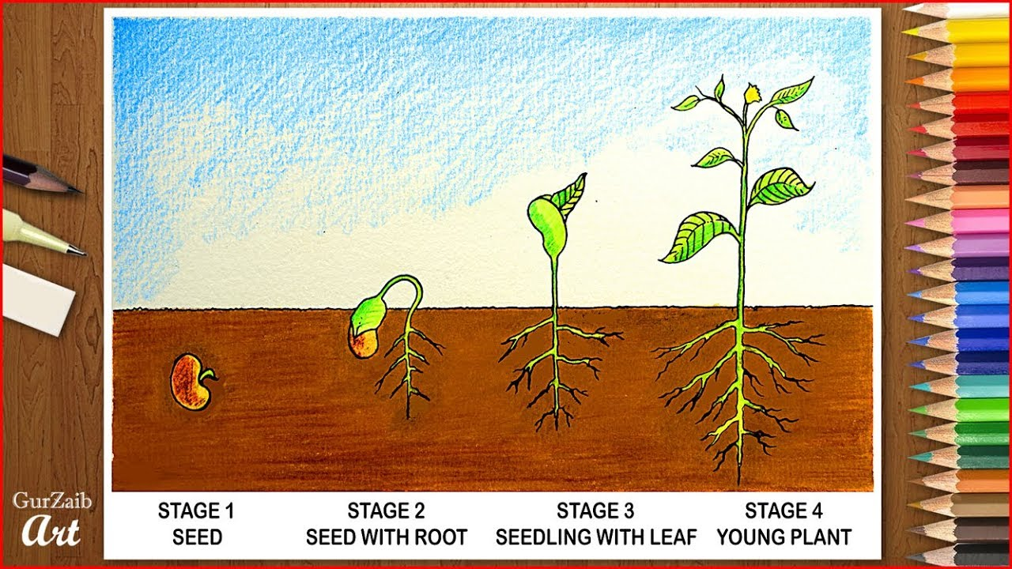
Beginner/Novice Approaching Proficient/Meeting Expert/Advanced

 | I can: | You did it! | We can work on this :)
1. | Meet the learning target

1st Grade Expedition One Final Product Rubric: Warm Sun, Cool Moon
 | I can: | You did it! | We can work on this :)
1. | draw wavy lines and straight, radiating lines.
2. | draw organic lines
3. | draw geometric lines
4. | follow a directed drawing to create my facial features
5. | identify warm colors by only using warm colors to color in the space on the sun side of my paper.
6. | identify cool colors by only using cool colors to color in the space on the moon side of my paper.
7. | Trace all of my pencils lines with black marker (or colored pencil if no marker is available) neatly so that my lines stand out.
8. | fill my entire picture plane in with color using my assigned art tools.

Craftsmanship: Crayon, Colored Pencil, and Marker
Beginner/Novice | Approaching | Proficient/Meeting | Advanced/Expert
1 | 2 | 3 | 4
- Only one color is used  - Color frequently goes outside of the lines  - Color marks move in multiple directions  - Lots of white spaces left | - Color is almost totally inside the lines  - More than one color was used  - Minimal white spaces | - Color is inside the lines  - Color marks move in the same direction  - Shape is totally filled with color  - Colors make sense | - Color is inside the lines  - Variety of colors are used--each shape/section is a different color  - Color marks move in the same direction  - Shape is totally filled with color  - Colors make sense  - Colors are blended together gradually

2nd Grade Expedition One Final Product Rubric: Scientific Fossil Illustration
 | I can: | You did it! | We can work on this :)
1. | use shapes to help me draw my fossil.
2. | draw my fossil so accurately a viewer could identify my fossil without it being labeled.
3. | draw my fossil big so that it takes up at least ½ of my picture plane.
4. | reflect and improve on each draft.
5. | trace all of my pencils lines with black marker (or colored pencil if no marker is available) neatly so that my lines stand out.
6. | fill my entire fossil in with color using my assigned art tools.

Craftsmanship: Colored Pencil
Beginner/Novice | Approaching | Proficient/Meeting | Advanced/Expert
1 | 2 | 3 | 4
- Only one color is used  - Color frequently goes outside of the lines  - Color marks move in multiple directions  - Lots of white spaces left | - Color is almost totally inside the lines  - More than one color was used  - Minimal white spaces | - Color is inside the lines  - Color marks move in the same direction  - Shape is totally filled with color  - Colors make sense | - Color is inside the lines  - Variety of colors are used--each shape/section is a different color  - Color marks move in the same direction  - Shape is totally filled with color  - Colors make sense  - Colors are blended together gradually

3rd Grade Expedition One Final Product Rubric: Freaky Frog Illustration
 | I can: | You did it! | We can work on this :)
1. | draw the shape of my frog accurately.
2. | draw all the identifying features of my frog (i.e. spots, lines, texture etc)
3. | Draw an accurate setting/habitat in the background around my frog.
4. | reflect and improve on each draft.
5. | trace all of my pencils lines with black marker (or colored pencil if no marker is available) neatly so that my lines stand out.
6. | fill my entire illustration in with color using my assigned art tools.

Craftsmanship: Colored Pencil
Beginner/Novice | Approaching | Proficient/Meeting | Advanced/Expert
1 | 2 | 3 | 4
- Only one color is used  - Color frequently goes outside of the lines  - Color marks move in multiple directions  - Lots of white spaces left | - Color is almost totally inside the lines  - More than one color was used  - Minimal white spaces | - Color is inside the lines  - Color marks move in the same direction  - Shape is totally filled with color  - Colors make sense | - Color is inside the lines  - Variety of colors are used--each shape/section is a different color  - Color marks move in the same direction  - Shape is totally filled with color  - Colors make sense  - Colors are blended together gradually

4th Grade Expedition One Final Product Rubric: Animal Adaptation Portrait
 | I can: | You did it! | We can work on this :)
1. | draw the shape of my expert animal’s head and body (if visible in my expert photograph) accurately.
2. | draw all of my animal’s facial features.
3. | draw implied texture on my animal’s face using shapes and lines as well, usingTamara Phillips’ art as inspiration.
4. | draw radiating wavy lines in the background around my animal.
5. | trace all of my pencils lines with black marker (or colored pencil if no marker is available) neatly so that my lines stand out.
6. | Identify analogous color groups by using one analogous color group to add color to my artwork.
7. | fill my entire illustration in with color using my assigned art tools.

Craftsmanship: Colored Pencil
Beginner/Novice | Approaching | Proficient/Meeting | Advanced/Expert
1 | 2 | 3 | 4
- Only one color is used  - Color frequently goes outside of the lines  - Color marks move in multiple directions  - Lots of white spaces left | - Color is almost totally inside the lines  - More than one color was used  - Minimal white spaces | - Color is inside the lines  - Color marks move in the same direction  - Shape is totally filled with color  - Colors make sense | - Color is inside the lines  - Variety of colors are used--each shape/section is a different color  - Color marks move in the same direction  - Shape is totally filled with color  - Colors make sense  - Colors are blended together gradually

5th Grade Expedition One Final Product Rubric: Natural Disaster Rainbow Scratch Art Illustration
 | I can: | You did it! | We can work on this :)
1. | draw my natural disaster accurately so that a viewer could identify what it is without my work being labeled.
2. | block out the major shapes and lines of my expert photograph onto my final draft picture plane.
3. | identify the highlights/lighter values in my photograph as evidenced by my mark making placements.
4. | identify the shadows/dark values in my photograph as evidenced by my mark making placements.

Craftsmanship: Mark Making (Line Patterns)
Beginner/Novice | Approaching | Proficient/Meeting | Advanced/Expert
1 | 2 | 3 | 4
- Only one kind of Line Pattern is used  - Line Patterns frequently overlap or look scribbled  - Line are drawn hap haphazardly and with no clear sense of a pattern or purpose  - Little to no space is left between lines | - Two to three kinds of line patterns are used.  - Some effort was taken while lines patterns were drawn.  - Some line patterns were drawn with thought or a plan.  - Some space was left between lines. | - Many kinds of line patterns were used.  - Lines are solid and deliberately applied.  - Line patterns reflect aspects of the artwork (i.e. a wavy line pattern was used to show where water is in the artwork)  - Lines show a sense of direction (i.e. if wind is blowing from left to right, the line pattern moves in the same direction) | - Many kinds of line patterns were used.  - Lines are solid and deliberately applied.  - Line patterns reflect aspects of the artwork (i.e. a wavy line pattern was used to show where water is in the artwork)  - Lines show a sense of direction (i.e. if wind is blowing from left to right, the line pattern moves in the same direction)  - Line size and shape vary  - The whole picture plane is filled with line.

