Kindergarten Expedition Two: Visual Arts Final Product Rubric

Stages of Learning Growth
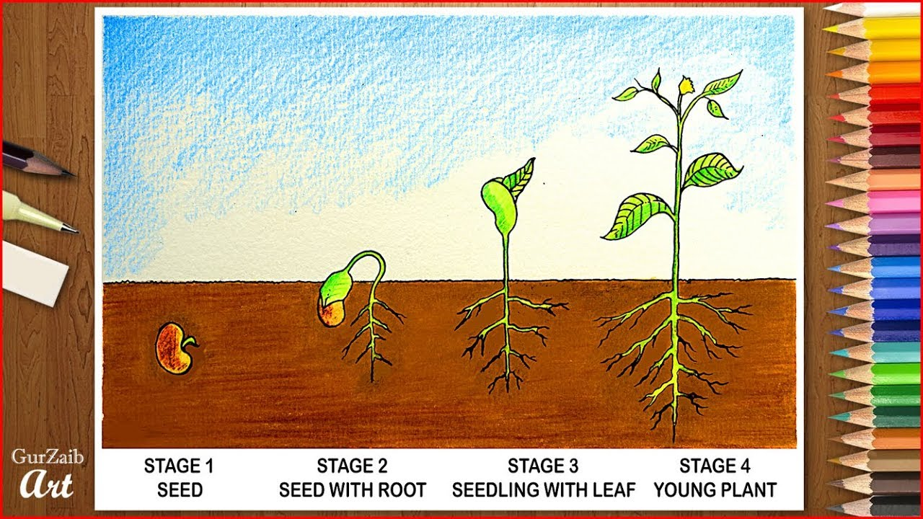
Beginner/Novice Approaching Proficient/Meeting Expert/Advanced

 | I can: | You did it! | We can work on this :)
1. | Meet the learning target

Kindergarten Grade Expedition Two Final Product Rubric: Community Mosaic Portrais
 | I can: | You did it! | We can work on this :)
1. | identify a member of my Community by choosing a person to draw a portrait of.
2. | draw a person using shapes.
3. | practice my drawing skills by using step by step drawing guides.  This will help me to draw these things on my own later.
4. | apply the skills I learned and practiced last week to the Second Draft of my Community Mosaic Portrait.
5. | Accurately draw the facial features of my chosen Community Member.
6. | Draw my community member’s hair.
7. | Trace all of my pencil lines with a black coloring tool.
8. | fill my entire picture plane in with color using my assigned art tools.

Craftsmanship: Crayon, Colored Pencil, and Marker
Beginner/Novice | Approaching | Proficient/Meeting | Advanced/Expert
1 | 2 | 3 | 4
- Only one color is used  - Color frequently goes outside of the lines  - Color marks move in multiple directions  - Lots of white spaces left | - Color is almost totally inside the lines  - More than one color was used  - Minimal white spaces | - Color is inside the lines  - Color marks move in the same direction  - Shape is totally filled with color  - Colors make sense | - Color is inside the lines  - Variety of colors are used--each shape/section is a different color  - Color marks move in the same direction  - Shape is totally filled with color  - Colors make sense  - Colors are blended together gradually

