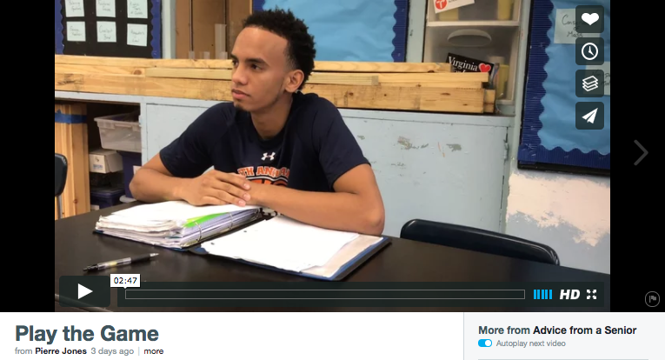

vimeo.com/194454287

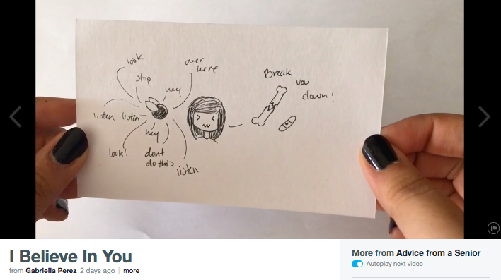

vimeo.com/194519481

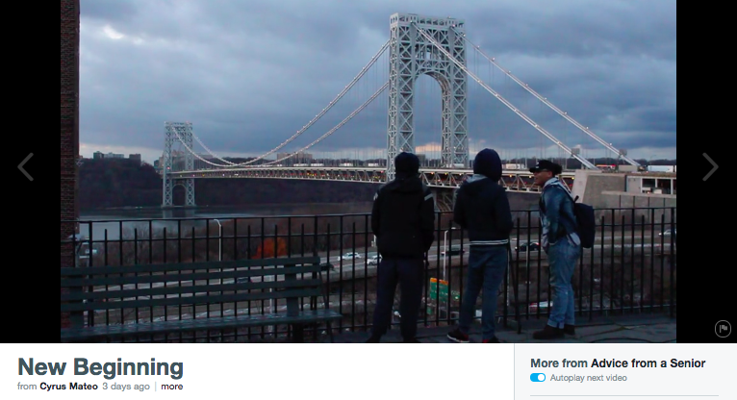

vimeo.com/194438394

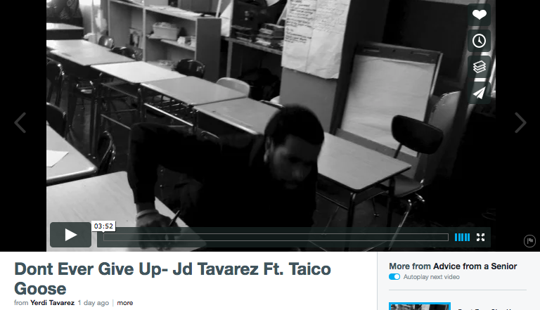

vimeo.com/194661053

Rationale:

In an “Introduction to Rhetoric” unit, Seniors at WHEELS studied various commencement and convocation speeches and wrote rhetorical analysis essays around the essential question, “How can words compel action?” Then, using a newly acquired rhetorical toolkit, students crafted motivational speeches for incoming ninth grade students at WHEELS.

Students drafted, revised, and rehearsed speeches and took their work through a peer critique protocol. Then, students recorded and produced their work using iMovie and other digital production software. Finally, students published their final speeches on the Vimeo digital platform and shared their work with the ninth grade community during crew and English class.

Using a scoring tool, ninth graders viewed and rated each speech on effectiveness of message, persuasive appeal, and craftsmanship. The top speeches were played at a ninth grade community meeting where seniors were present to answer questions about the challenges of high school.

How can words compel action?
Motivational Speech: Advice from a Senior

Context: As a senior, you have an infinite amount of experience and wisdom to offer our school community. What kind of community do you want WHEELS to be? What would you have wanted to hear as a freshman? How can you use words to both leave a legacy and inspire future community members? What advice would you give to an incoming freshman about how to approach their high school experience?

Task: Write a motivational speech and accompanying personal video to a current ninth grade student.

Target audience: Ninth grade students at WHEELS; someone like you.

