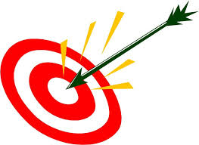
I can reflect on my progress and know it is not a final draft YET!
I can make revisions to improve the realism of my planet.

Name: ________________
Date: _________________

What did you do well?

How will you revise the color of your planet to make it even more realistic? What colors will you use?

How will you revise the texture of you planet to make it even more realistic?

How will you change the way you use the tools (bowl, spray can, scrapers, fingers) to make your planet more realistic?

Does your planet need rings?

